**Lab - Clustered Bar Chart, Clustered Column Chart**

**Step 1:**Click on the **Legend**option. A drop-down appears. We have multiple options available here i.e. **Options**, **Text**, and **Title**. We can set the position of the legends. Using the **Text**property, we can change the **color**and **font**size of the legends i.e. **Department**. Click on the **Title**, to customize the title i.e. **Department**.

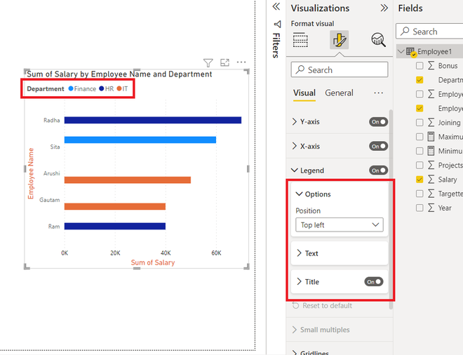

**Step 2:**Click on the **Options**property, and a drop-down appears. We can set the position of the legends accordingly. For example, to **Top Center**, **Bottom left,** etc. By default, the**Top left** is the position.

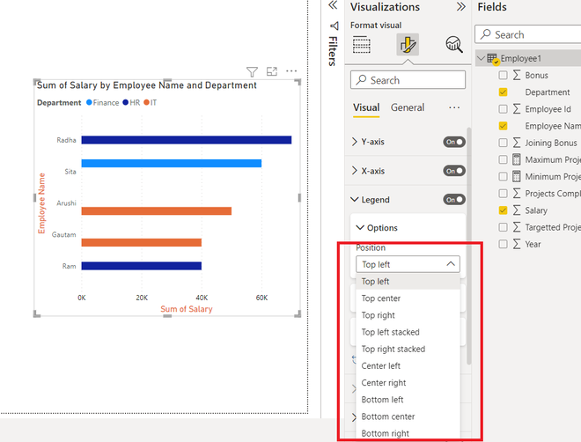

**Gridlines**

**Gridlines**are the background lines, which are by default **dotted**in nature, and are very light and thin.

**The following are the steps:**

**Step 1:**Click on the **Gridlines**option. A drop-down appears. We have an option available i.e. **Vertical**.  Click on the **Vertical**option, and a drop-down appears. By default, in **clustered bar charts** only vertical gridlines are available. We can edit the **style** of the line. Also, one can set the **color**and change the **thickness**of the gridlines.

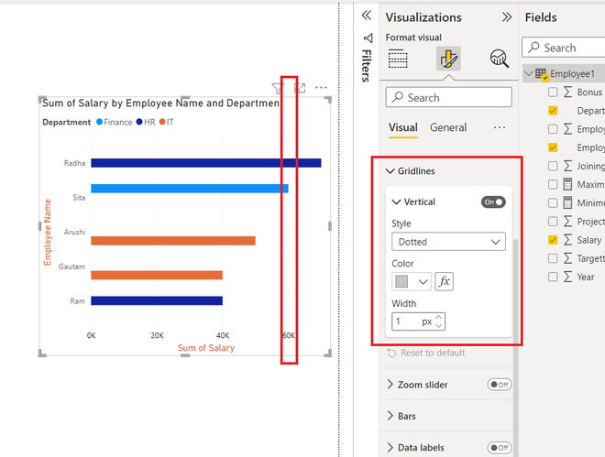

**Step 2:**Under the **Style**option, click on the drop-down option. A list appears. We can change the **style**of the**vertical gridlines**to **solid**, **dashed,**etc.

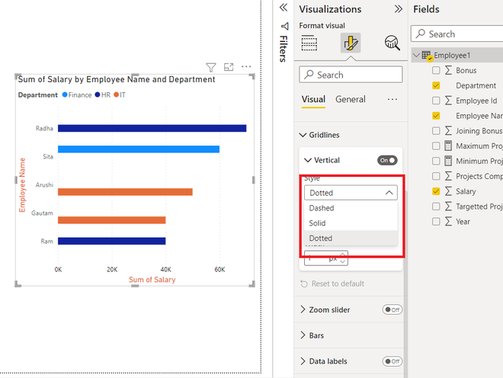

**Step 3:**If we close the slider of the **Vertical gridlines**, then the vertical lines would disappear, as seen in the image below.

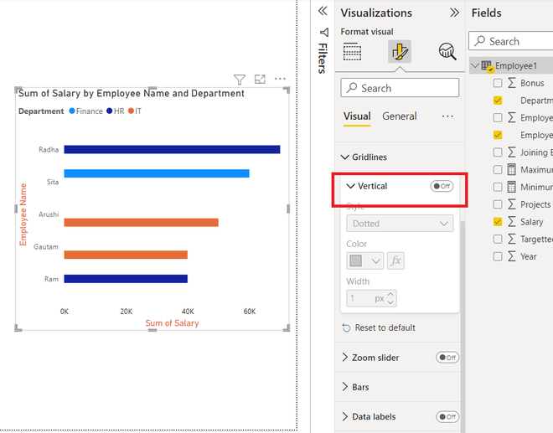

**Zoom Slider**

The zoom slider is used to increase or decrease the range of the numeric values on the x-axis.

**The following are the steps:**

**Step 1:**Click on the**Zoom slider** option. A drop-down appears. We have multiple options available here i.e. **X-axis**,**Slider labels**, and **slider tooltips**. A slider will appear on the**x-axis**of the clustered bar chart.**Slider labels,** enable the values on the slider as a mark strip. **Slider tooltips** is used whenever we are sliding the zoom slider, the numeric value will appear on it.

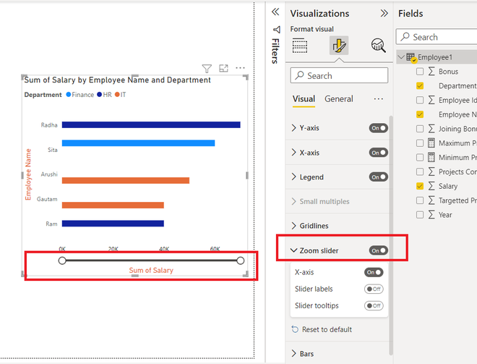

**Step 2:**The below gif shows how the bars change with the slider.



**Bars**

**Bars**refer to the rectangular columns, which show the dataset value corresponding to each y-axis value in clustered bar chart. Click on the Bars option. A drop-down appears. We have two options i.e. **Color**and **Spacing**. We can customize the **color**of the bars accordingly, and can also add **padding**between the bars.

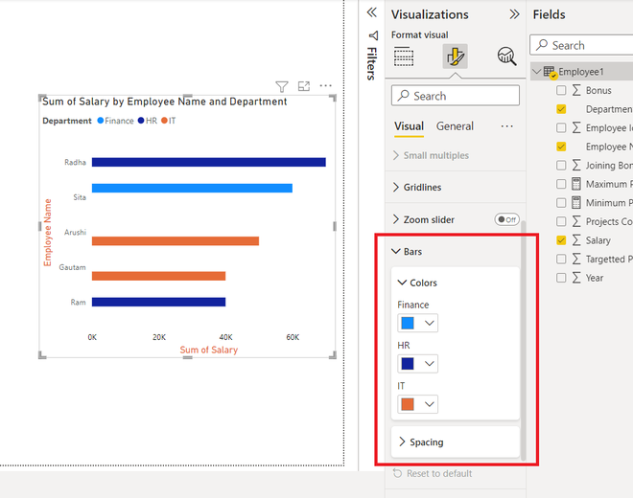

**Data Labels**

**Data labels** provide additional information on the bars. For example, **Arushi**has a salary of **50K**, and she wants to display that on the bar. Click on the Data labels option. The **salary**data label will be added to the entire chart. Also, a drop-down appears. We have **four**options i.e. **apply settings** **to**, **options**, **values,**and **background**. **Values**and **background**have the same property as discussed above i.e. **font**, **size,**and **color**. **Apply** **settings to**, is a filter on the basis of **legends**, we can apply the property to specific groups only. The **options**property is used to set the **position**of the data labels.

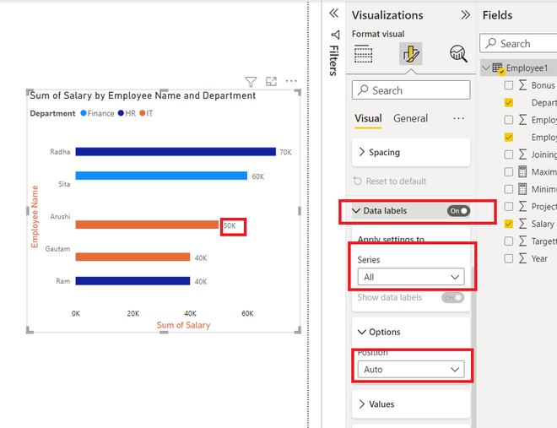

**General Formatting**

There are multiple options in **general formatting.** For a **clustered bar chart,** we have options like Title, tooltip, effects, alt text, etc. We will look at each of the options in detail.

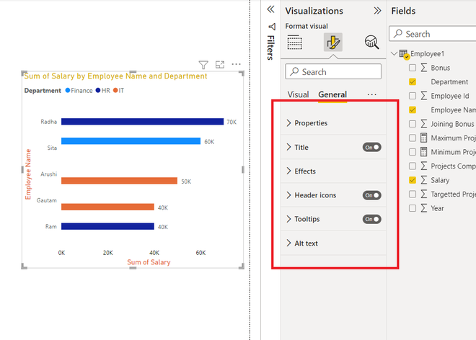

**Property**

The **property**option is generally present in every visualization. It contains **three**options, **Size**, **position**, and **Advance options.** We, generally do not use these properties, because all are easily accessible with **mouse clicks.**The **size** property helps to resize the visualization created. The **position**property changes the position of the visualization, in the report. The **Advance option** comprises adding a**layer order**, which is rarely used.

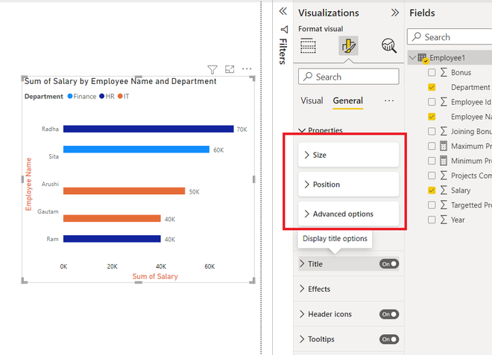

**Title**

The **title**formatting is present in every visualization. As the name suggests, it adds a heading to the visualization. Click on the slider to enable the title.

**The following are the steps:**

**Step 1:** Click on the **Title**option. A drop-down list appears. Add the **title**, under the **Text**section. For example, **Sum of Salary by Employee Name and Department**. We can view in the image a title is added to the chart. As done previously we can customize the **size**, **font**type of the chart, etc.

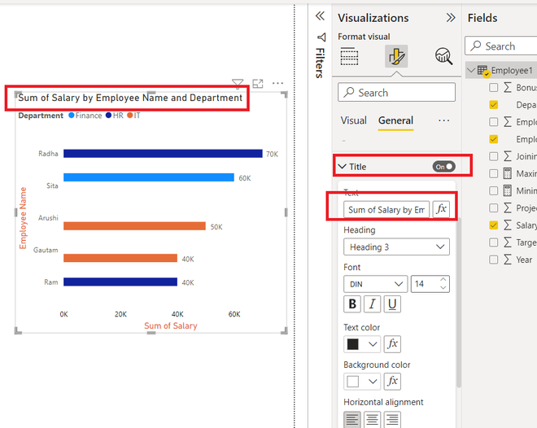

**Step 2:**We can also change the **color**of the title. Under the **text**color, select the required color. For example, **yellow**in this case. The title color changes to **yellow**.

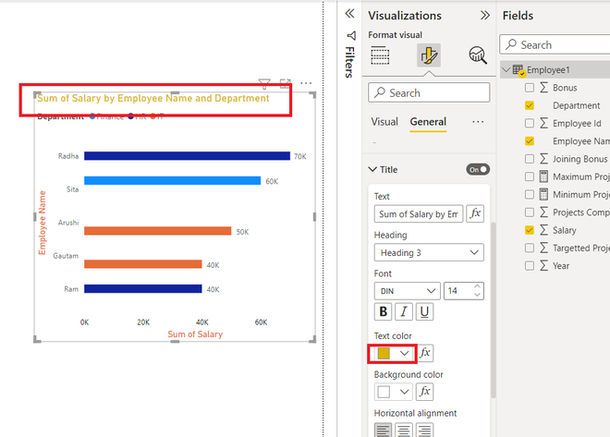

**Effects**

The **effects**section comprises **three**features i.e. **Background**, **Visual Border**, and **Shadow**. All works according to their names. The **background**adds a background color to the visualization, the **Visual borde**r adds a **border**around the visualization, and the **shadow**option creates a shadow on the outskirts of the visualization.

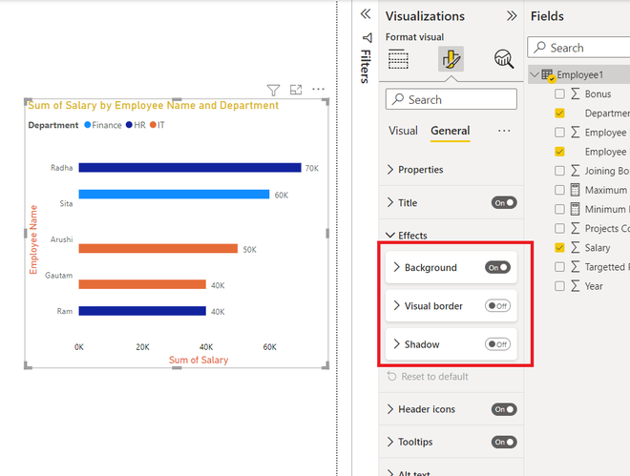

**The following are the steps:**

**Step 1:**Click on the **Background**option. Select the color of the background accordingly. For example, **Pink**. We can view in the below image that the background of the chart changed to pink.

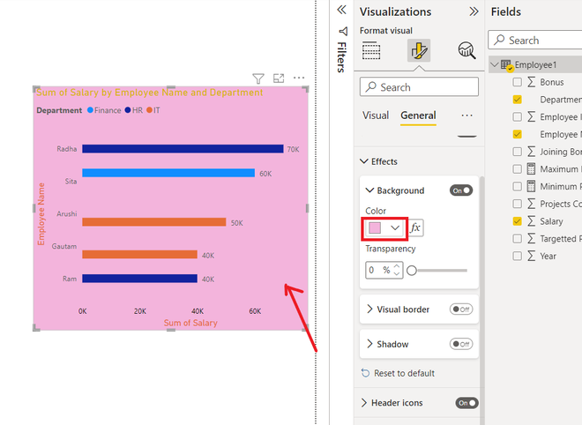

**Header Icons**

**Header-icons**are the options, present on the top of the visualization. For a **clustered bar chart,**there are **two**options,**filter on visuals** and **more options**. Click on the header-icons option, we will get various options, like **Background**, **Border**, and **Icons**. One can set its colors as per choice.

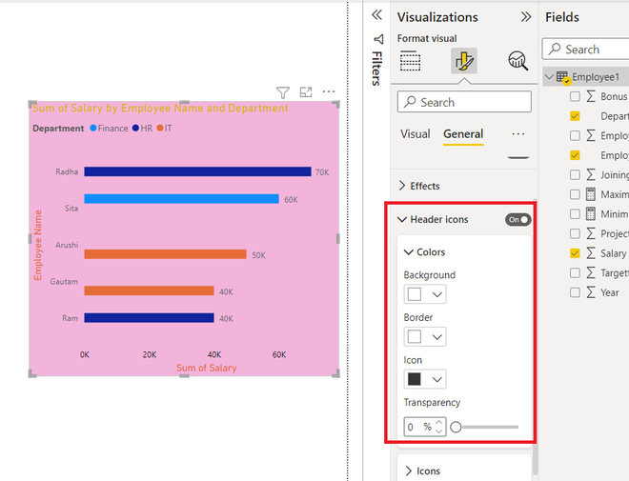

**Tooltips**

If we **hover**over a visualization, then we cannot view any information related to the chart. Consider a situation, where we want to display the fields added on hovering over the chart, then this task can be achieved by the **Tooltips**option. Tooltips have **three**properties i.e. **Options**, **Text**, and **Background**. Click on the **tooltips**option. Now, for example, we hover over the bar, then we can view that the **employee Name Arushi, Department IT,**and **Salary 50K**is displayed. We can set **text**and **background**color according to our needs.

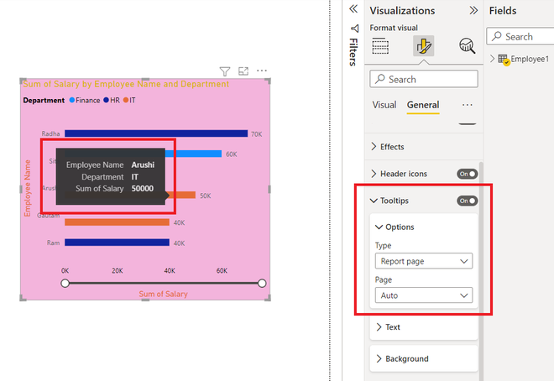

**Alt Text**

**Alt text** is a property present in each visualization. People generally misinterpret, alt text by its name, they think that alt text will be displayed when they hover over the visualization. Alt text is for the persons, who cannot see the visuals, images, etc. This option is only available if you are using a **narrator**in your system. When your narrator is active, then this alt text will be spoken by the system. Click on the**Alt text**, and type the required text.

